Functional Instructions

# View Transaction History:

* User can view the transaction history from the data provided in data/transactions.json file.

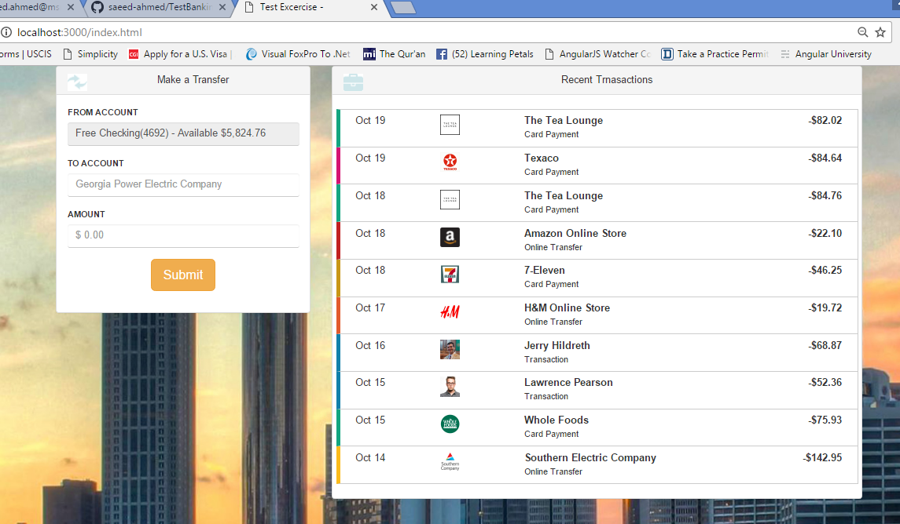

# New Transaction:

* User can make a new transaction by filling the **To Account & Amount** fields.
* Pressing **Submit** button will show **Confirm Transaction** screen with the user changes.

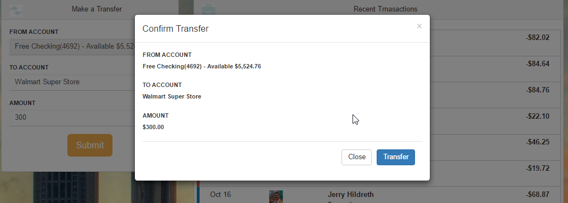

* To make a new transaction user need to click **Transfer** button.
* The newly transaction will be added and can be seen in transaction history screen.

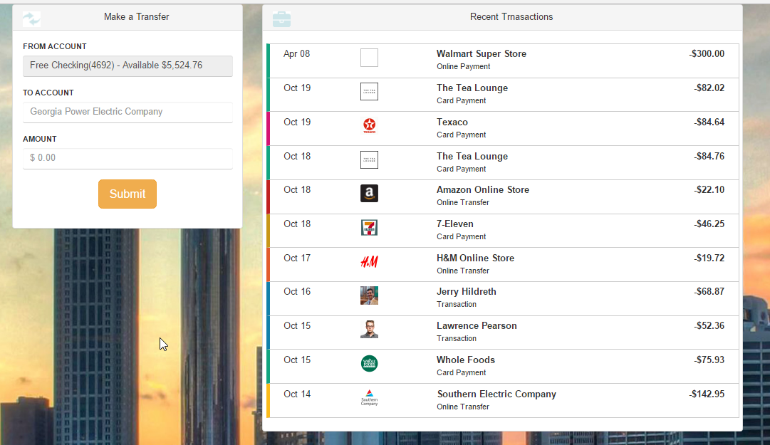

* Once the new transaction is made the available balance will be debited accordingly.
* User can cancel the transaction by clicking **Close** button